1. **Agenda**:
   1. Unit Test for Native Query with named params using Spring Data JPA.
2. Let’s first add the native query to the EmployeeRepository.java
3. A screenshot of a computer

   Description automatically generated with medium confidence
4. 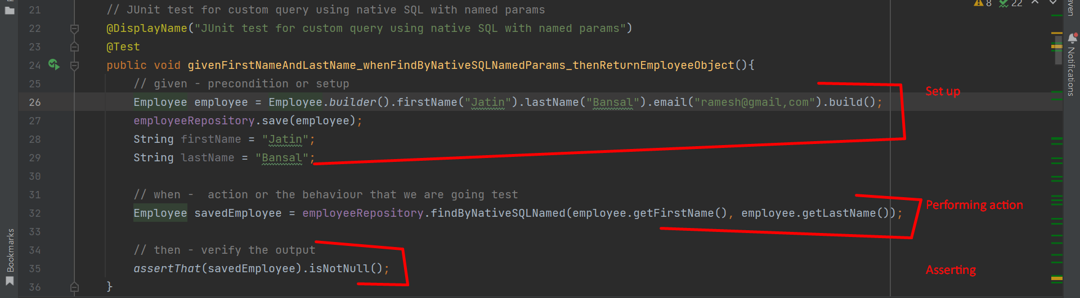
5. **Output**:  
   A screenshot of a computer

   Description automatically generated with medium confidence